MAP QUESTIONS

- INTRO

It is important that people get familiar with the map and how to orientate on it!
- Show the map! Talk about it (the legend, villages, present the railway, Kibera Drive, etc)!
- Make a mark where you live! (Very important!) - MAKE A MARK (BLACK)

QUESTIONS:
Individuals should focus first on the village where they live – than broader!
- What do you think about the map?
- Is it representative?
- What is missing – MAKE A MARK (RED)?
- Which facilities work and which don’t – MAKE A MARK (RED)?
- Which are the most reliable/trustworthy – MAKE A MARK (GREEN)?

- WHICH SERVICES ARE USED (BLACK)

- Start with where people live!

QUESTIONS:
- Where do you go for services? (Very important!) - MAKE A MARK (BLACK)
- Why? (Very important!) – write beside the service why people use it!
- Do you use health services outside of Kibera and which?

This question might present a problem, because people go to visit different services based on the problem they are facing – so if needed try to build your questions around these:
- GENERAL PRACTICIONER
- DENTAL
- CHEMIST
- BIRTH/MATERNITY CENTRE/MIDWIFE/PEDIATRICIAN
- LABORATORY/HIV
- MENTAL/PSYHIATRIC COUNSELING
- EYE
- X-RAY

- Make a mark in the middle of the villages which present the whole community and ask the same questions:

- Where do your relatives and friends and community in general go for services? (Very important!) - MAKE A MARK (BLACK)
- Why? (Very important!) – write beside the service why people use it!
- Do they use health services outside of Kibera and which?

- THINGS TO IMPROVE (BLUE)

- What’s the biggest need/health problem?
- What services are unavailable in Kibera?
- Where would you put the health service and which kind? - MAKE A MARK
- Any 24 hours services? - MAKE A MARK
- Any redundancy?
- Who are the important people that aren’t mapped here responsible for health provision?
And
- What would you want health service provider to know about Kibera?
- If you were talking to health official about this map and health, what would you tell?

You can ask the same questions to verify!
- Best & Worst services? - MAKE A MARK

- PERSONAL STORIES (YELLOW)

- Any personal stories of when you had trouble accessing services and where did it happen?

Hope to get something like this:
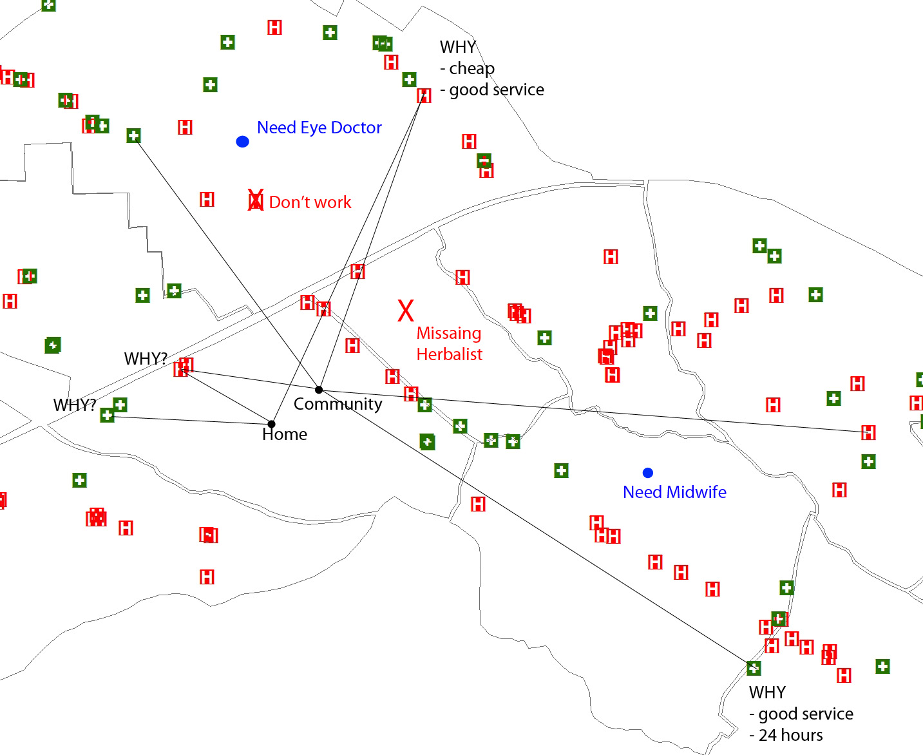
- went to the doctor, waited 8 hours didn't get treated!

