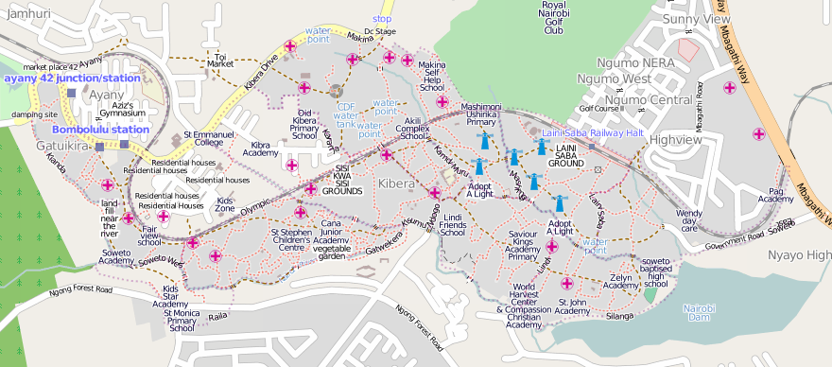
Map Kibera
http://mapkibera.org/
http://kibera.ushahidi.com/
contact@mapkibera.org
0724899738

Map Kibera has produced the first complete, free and open map of Kibera. In November 2009, local motivated young people learned to create maps using open source techniques. We will now add large amounts of data to the map around 3 categories (health services, public safety/vulnerability and informal education) then experiment with ways for vulnerable populations (with a special emphasis on young girls and women) can increase awareness and the ability to advocate for better service provision.

Map Kibera
http://mapkibera.org/
http://kibera.ushahidi.com/
contact@mapkibera.org
0724899738

Map Kibera has produced the first complete, free and open map of Kibera. In November 2009, local motivated young people learned to create maps using open source techniques. We will now add large amounts of data to the map around 3 categories (health services, public safety/vulnerability and informal education) then experiment with ways for vulnerable populations (with a special emphasis on young girls and women) can increase awareness and the ability to advocate for better service provision.

Map Kibera
http://mapkibera.org/
http://kibera.ushahidi.com/
contact@mapkibera.org
0724899738

Map Kibera has produced the first complete, free and open map of Kibera. In November 2009, local motivated young people learned to create maps using open source techniques. We will now add large amounts of data to the map around 3 categories (health services, public safety/vulnerability and informal education) then experiment with ways for vulnerable populations (with a special emphasis on young girls and women) can increase awareness and the ability to advocate for better service provision.

