Map Kibera
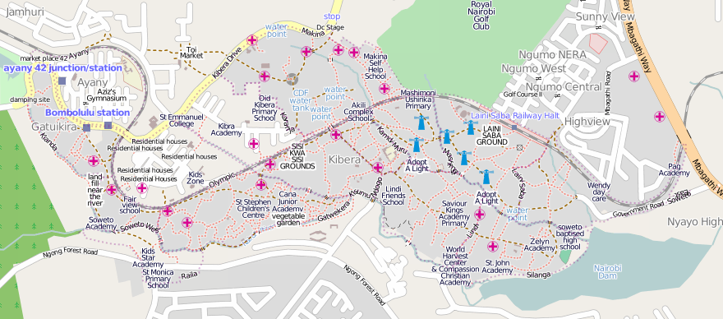

Nairobi, Kenya
http://mapkibera.org
contact@mapkibera.org
0724899738

25th May, 2010
To whom it may concern
We at Map Kibera hope that this letter finds you in good health.

Map Kibera has produced the first complete free and open map of Kibera, for use by people in Kibera. In November 2009, local motivated young people learned to create maps using “OpenStreetMap” techniques. This included surveying with GPS and use of advanced open source software. Individuals from the blossoming Nairobi tech scene helped train and make connections with the larger community, and created a sustainable group of mappers beyond the initial three week November effort. We have, and continue to, consult in depth with groups, local administration, and individuals, in Kibera on how they can utilize the map and other data sources. In this line, we have launched the Voice of Kibera [http://kibera.ushahidi.com/], and soon we will be distributing paper maps throughout Kibera.

We are presently adding large amounts of data to the map around 4 categories (health services, public safety/vulnerability, education, and water/sanitation), and developing ways for vulnerable populations (with a special emphasis on young girls and women) can increase awareness and the ability to advocate for better service provision. We hope that your institution can participate. If you have any queries, please do not hesitate to get in touch.

Sincerely,
Mikel Maron
Map Kibera Coordinator

