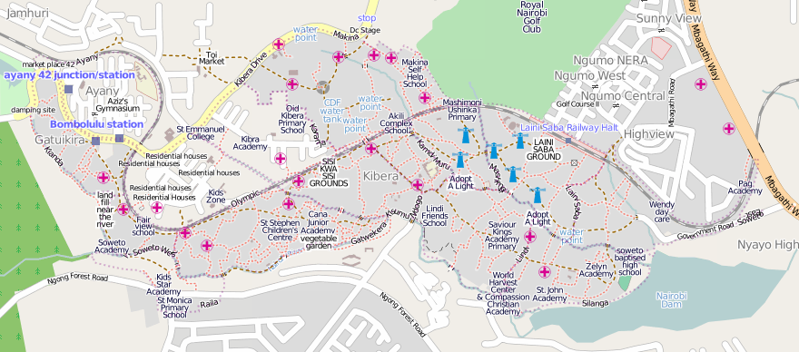
Map Kibera
http://mapkibera.org/
http://kibera.ushahidi.com/
contact@mapkibera.org

Map Kibera has produced the first complete, free and open map of Kibera. In November 2009, local motivated young people learned to create maps using open source techniques. We are now adding large amounts of data to the map concerning health services, public safety/vulnerability, water/sanitation and informal education, then experimenting with ways for Kibera residents to increase awareness and advocate for better service provision in their community.
The Map Kibera map is available online at http://mapkibera.org/ and is free for anyone to use. To keep up-to-date with the project or learn how you can help, visit the wiki at http://mapkibera.org/wiki and the blog at http://mapkibera.org/blog.
Paper copies of the map are also being printed and shared with residents through community meetings. Paper maps will eventually be shared with local organisations throughout Kibera.

Map Kibera
http://mapkibera.org/
http://kibera.ushahidi.com/
contact@mapkibera.org

Map Kibera has produced the first complete, free and open map of Kibera. In November 2009, local motivated young people learned to create maps using open source techniques. We are now adding large amounts of data to the map concerning health services, public safety/vulnerability, water/sanitation and informal education, then experimenting with ways for Kibera residents to increase awareness and advocate for better service provision in their community.
The Map Kibera map is available online at http://mapkibera.org/ and is free for anyone to use. To keep up-to-date with the project or learn how you can help, visit the wiki at http://mapkibera.org/wiki and the blog at http://mapkibera.org/blog.
Paper copies of the map are also being printed and shared with residents through community meetings. Paper maps will eventually be shared with local organisations throughout Kibera.

